**STRUCTURE OF PROJECT PROGRESS REPORT**

**TITLE PAGE**

(i) Title

- A concise statement of the main topic and should identify the variables.

- Should be a reflection of the contents of the document.

- Fully explanatory when standing alone.

- Should not contain redundancies such as ‘a study of…..or ‘an investigation of……

- Abbreviations should not appear in the title.

- Scientific names should be in italics.

- Should contain 12 to 15 words.

(ii) Author’s name and affiliation

- Avoid use of words like ‘By…..’ ‘from…..’

- Preferred order of names- start with your surname, middle name then last name

- Affiliation should be well illustrated i.e.

‘A project submitted to the Department of ………in the School of Computer Science and Information Technology in partial fulfillment of the requirements for the award of the degree of …….. Dedan Kimathi University of Technology’

- The year should follow at the bottom of the caption.

**DECLARATION**

- Should include both the candidate’s and the supervisor’s declaration and duly signed.

- Full names should be used, initials should be avoided. For example:

This proposal is my original work and has not been presented for a degree in any other University

Name: …………………………………………………………..

……………………….…. …………………

Signature Date

This proposal has been submitted for examination with my approval as University

Supervisor

Name: …………………………………………………………..

……………………… ……………….

Signature Date

**ABSTRACT**

- This is a brief statement of the problem, objectives of the study, methodology, data processing and analysis, key findings, general impact of your project and major recommendations.

- Should not exceed 1000 words.

**TABLE OF CONTENTS**

- The rubric should be in title case and single spaced.

- The chapter titles should be in caps and bold.

- The subheadings should follow each chapter title and should be in title case.

- Subheading of rows should be – Chapters & Pages indicated once at the top of each column

**Example:**

**CHAPTER ONE: INTRODUCTION**

1.1 Introduction ……………………………1

1.2 Statement of the problem………………2

**REFERENCE**

**APPENDICES**

**LIST OF TABLES**

- List of tables

**LIST OF FIGURES**

- List of figures

**DEFINITION OF TERMS**

- Define terms in the text that are not common.

**CHAPTER ONE**

**INTRODUCTION**

1.1 Background

- Should show the understanding and genesis of the problem.

- Talk about the global perspective followed by the local scenario.

- Talk about the target group in the study.

- Should be approximately 4-6 pages.

1.2 Statement of the problem

- Must indicate exactly what the problem is.

- Indicate why and how it is a problem. Give information to support this e.g. by use of statistics or evidence. This should be derived from background information to illustrate connectivity. Reference properly done.

- Length - Maximum 1 page.

1.3 Objectives

General Objective

- One general objective which should be in line with the title.

Specific objectives

- Should be related to the general objective.

- Maximum of 5 objectives and a minimum of 3 objectives

- Should be numbered in romans e.g. (i), (ii), (iii).

- Should start with statements such as: “To investigate…”, “To evaluate…”, “To find out…”

You should AVOID statements such as “To Study…”

- Objectives should be SMART

1.4 Research Questions

- They should be in line with the specific objectives and equal in number.

- Should be questions and not statements

- Should be numbered in romans e.g. (i), (ii), (iii)

1.5 Justification

- Should illustrate why the researcher is conducting the research and whom it shall benefit. Maximum of one page.

1.6 Scope

- This is a kind of a disclaimer. Should cite the focus of the study geographical area or target group/ population etc. Maximum of one page.

1.7 Limitation

- **NOT** a must for a proposal.

- **MUST** to be there in the final project report.

- Indicate the challenges encountered in the study that may have limited the study.

**CHAPTER TWO**

**LITERATURE REVIEW**

This chapter should be a minimum of 5 pages.

2.1 Introduction

2.2 Case studies

2.2.1 Case study 1: Title

- Compare, contrast, critic, and synthesis of the existing literature relevant to the study

- Indicate what has been done by other researchers including the methodologies used and identify gaps.

- The hypothesized techniques should be subheadings of the literature review. Consistent in citation.

2.2.2 Case study 2: Title

- Compare, contrast, critic, and synthesis of the existing literature relevant to the study

- Indicate what has been done by other researchers including the methodologies used and identify gaps.

- The hypothesized techniques should be subheadings of the literature review. Consistent in citation.

2.2.3 Case study 3: Title

- Compare, contrast, critic, and synthesis of the existing literature relevant to the study

- Indicate what has been done by other researchers including the methodologies used and identify gaps.

- The hypothesized techniques should be subheadings of the literature review. Consistent in citation.

2.2.4 Case study 4: Title

- Compare, contrast, critic, and synthesis of the existing literature relevant to the study

- Indicate what has been done by other researchers including the methodologies used and identify gaps.

- The hypothesized techniques should be subheadings of the literature review. Consistent in citation.

2.3 Summary

- This should tone down the literature review.

- Indicate clearly weakness identified in the literature review.

- Should be a maximum of one page.

2.4 Research Gap

- Indicate the area that has not been explored by other researchers in the literature review.

- One paragraph is enough

2.5 Proposed methodology

- Indicate your proposed idea/ model/ architecture/ algorithm etc. All these must be relevant in the field of computing.

- Should be a maximum of one paragraph

**CHAPTER THREE**

**METHODOLOGY**

3.1 Introduction

3.2 Fact finding techniques

3.3 Software design - Software development procedures.

3.3 Preliminary Data Processing and analysis.

Etc.

**CHAPTER FOUR**

**Analysis and Design**

**4.1 Introduction –** introduce what system analysis and design is and what it entails

**4.2 Requirements Analysis**

These includes the functional and non-functional requirements

### 4.2.1. Functional Requirements.

The functional requirements define the capabilities and functions the system will perform successfully.

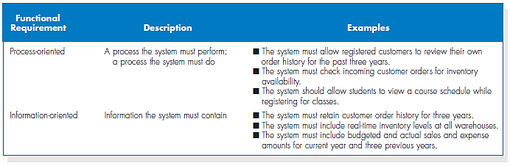

### 4.2.2. Non-functional Requirements.

The non-functional requirements define or describe attributes such as security, reliability, maintainability, scalability and usability that the system will have.

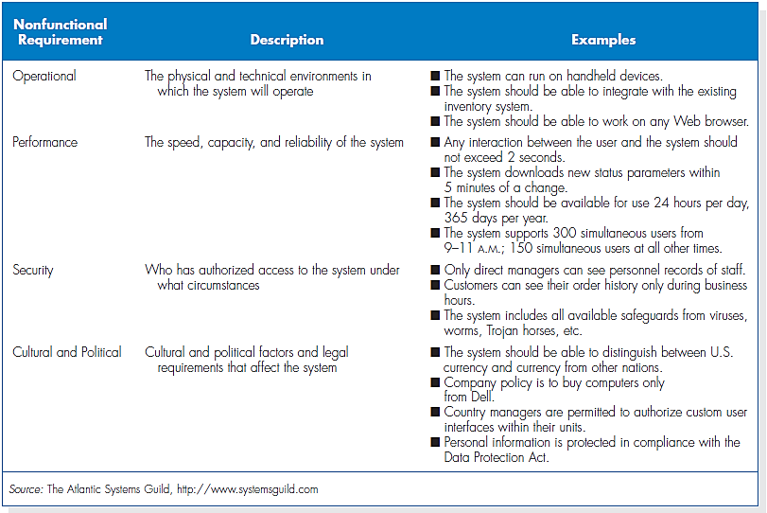

**4.3 Data Analysis**

Collect and analysis the data using the fact finding strategies described in chapter 3. Use charts and tables to describe and analyse the data. If questionnaires were used a sample of a filled-in questionnaire should be attached as an appendix

**4.3 System analysis**

Clearly explain what system analysis is. This includes

* Use case analysis,
* Process modelling techniques e.g. data flow diagrams (DFDs), context diagrams. UMLs, system flow charts etc.
* Data modelling e.g. entity relationship diagrams, data dictionaries

**4.4 System Design**

You should have at least three working components of the system clearly explained with sample user interfaces.

During presentation you will demonstrate the working of these components. Login interface is not counted as a working interface.

**REFERENCES**

Only literature that is available should be cited. Material not available through libraries, such as personal communications or unpublished data, should be given in text as parenthetical matter.

Make use of APA referencing style.

In general, references in the report text can be cited as follows.

For a single author: either Kirui (2000) or (Kamau, 2000).

For more than two authors: either Kirui et al. (2010) or (Kirui et al., 2010).

Referencing should be as follows.

a) Reference to periodical publications

Williams L A. Use of computer technology by family caregivers of patients undergoing blood or marrow transplants. Biology of Blood and Marrow Transplantation, 2006.

Brauner N; Schacham M. Identifying and removing sources of impression in polynomial regression. Mathematics and Computers in Simulation, 1998, 48: 75-91.

b) Reference to textbooks

Blanchard B S, Fabrycky W J. Systems engineering and analysis. New Jersey, Prentice Hall, 1998.

c) Reference to proceedings

Rigney M P; Kranzler G A. Seedling classification performance of neural network. Paper No. 897523, St Joseph, MI 49085, American Society of Agricultural Engineers, 1989.

**APPENDICES**

- Resources: categorised under hardware and software

- Ghant chart: Project time schedule

- Budget

- Samples of questionnaires and interview questions

**REPORT FORMATTING**

- Structure your report using Heading 1 Style for Chapters Titles, Heading 2 Style for Sub heading and Heading 3 Style for Sub-sub heading. Your report should have a maximum of three levels.

- Font – Times New Roman 12 should be used. Fancy fonts should be avoided.

- Use normal margin: One inch on Top, Right, Left and Bottom margins.

- Paragraphing should be consistent. Leaves space either after paragraphs or before paragraph.

- Line spacing should be 1.5

- One sentence paragraphs are unacceptable. A paragraph should have a minimum of five sentences.

- BE CAREFULL on grammatical and spelling mistake.

- This project should be your work.